What is redux ?

Redux is an libraries

Redux provides a complex architectures handel complex architectures type of projects

Redux used to stored data and manage state managements

Redux is used to load or update data via state management

Redux is an libraries of react js so we can isntall redux

Redux provides store where all data stored

Redux provides action and reducer it is a generalised function

Redux is used to dispatch actions to store to update data via state

Redux is help apps scale by providing a sensible way to manage state through unidirectional data flow model.

Redux is used to allow us to read data via react components from redux store

Redux provides a life cycle architectures
- state
- ui
- actions
- Reducer (simple generalised function)
- store

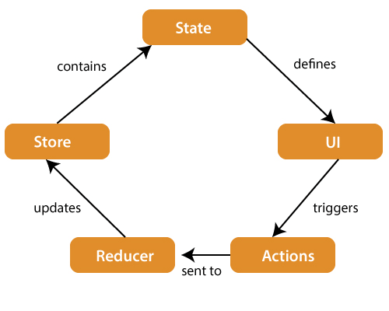

- State : state is instiaised data in an object
state is update data one components to another compone
state is manage data or used to update data
- UI : UI stands for user interface
create UI | Form | form via store
- Actions : An action is sent or dispatch from view or UI which are payloads that can be read data by reducer.
It is pure object crreated to store the information of user.
It includes information such as type of action , time of accurance
It is cordinates with reducer and sent data via or update data via state and used to stored data.

- Reducer : Reducer is one type of a generalised function
Reducer is read payloads from action and then performed update action via state.
It is a function that can be call a variables local or globals.
It is pure function to return view state from initial state.

- Store : A store is a place where your all or enitre state of your applications are listed that is called store.
A store just like a brain that is responsible for moving all data in redux.

What is advantage of redux ?

- Redux is an libraries of react js
- Redux is handel a complex applications
- Redux is used to manage state
- Redux is provides managebale architectures
- Redux is install via react js
6 Redux is provides tollkit
- Redux have a dispatch of data

How to install redux ?

1: npm create vite@latest
2: npm install redux react-redux --save
- npm install ui
- npm install axios
- npm react-router-dom

What is react life cycle ?

- intialisation
- Mounting
- Updating
- Unmounting

